Big Data

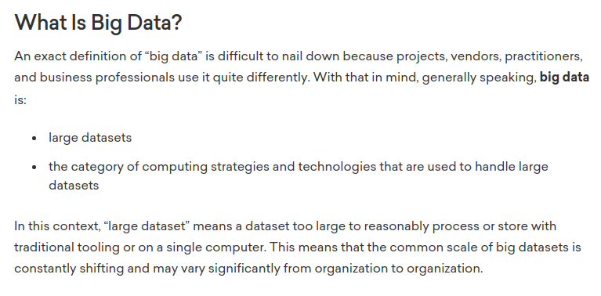

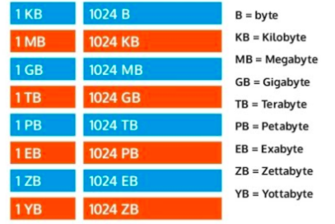

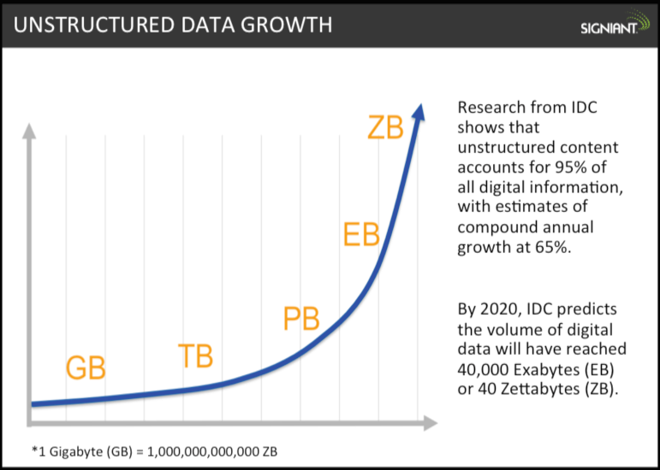

At the early state of computing, our computers needed very low space or hard disk to run. They were running on floppy disk with a very low memory. But eventually the demand for more space increased as we as users demands more and more data for our daily needs.

Now a days, the IT industries has to deal with Exabytes of data (that’s a lot of data). And eventually it will increase to Zeta byte -> Yotta byte and so on.

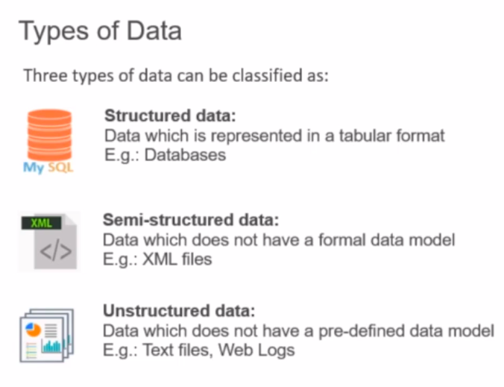

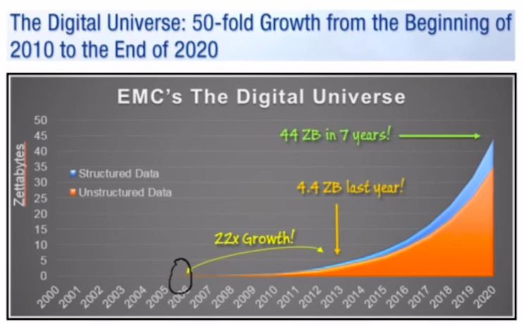

Structured data sources typically originated from transaction processing systems, which typically involve capturing the data related to a financial transaction.

Let’s talk about the word “Big Data” :
Big data is a mostly buzzword used to describe a massive volume of both structured and unstructured data which is very large and complex to process using traditional database and software techniques.

Majority of the data is going to belong to unstructured and semi-structured category.

The sources of big data can again be classified into two sub-category:

- Human Generated Data
- Computer Generated Data

Human Generated Data:

Blogs, Reviews, Emails, Pictures, Scientific Research, Medical Records.
Social Graphs: Facebook, Linked-in, Twitter

Computer Generated Data:

Application server logs (web sites, games, internet)

Sensor data (Weather, atmospheric science, astronomy, smart grids)

Images/videos (traffic, security cameras, military surveillance)

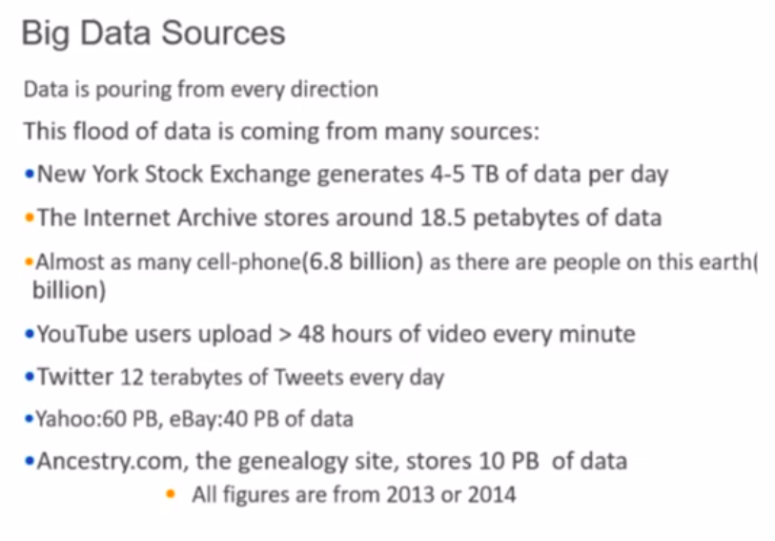

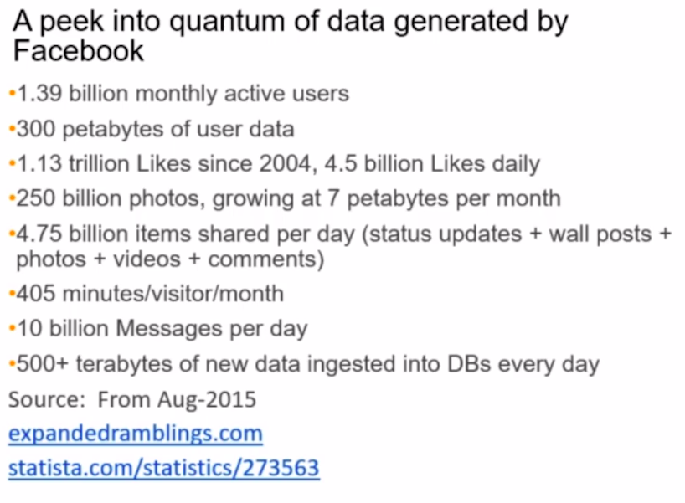

Why did the big data become so important in the recent years ?

- 90% of the data has been created in the last 2 years alone
- 80% of the data is unstructured which are difficult to analyze
- Structured formats limitations in handling large quantities
- Potentially valuable data is dormant or discarded

Reasons why Big Data is Appealing:

- Manage and process a huge amount of data cost efficiently
- Analyzes data in all forms un-/semi/structured, streaming, historical
- Captures data from fast-happening events in real time
- Handle failure of isolated nodes and tasks assigned to them
- Turn data into actionable insights

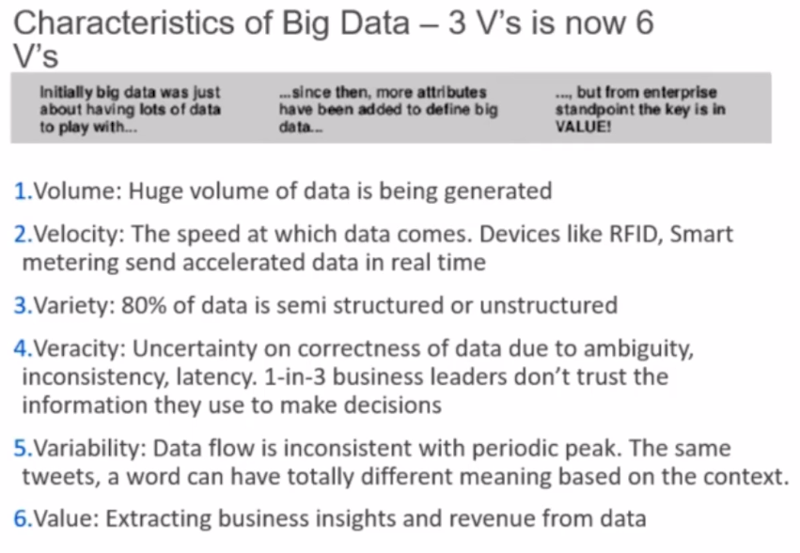

Veracity:

For example: Let’s say you are a zomato user and you went to a restaurant and you order a food. And then on that day, you rated the restaurant as 5. Now based on your review, the next user who visits the restaurant might not find it very interesting. So, here you have already rated the restaurant, but you were not very specific about what you have rated in the restaurant, the food, the ambiance, At what time you ordered. Supposed you ordered a meal, than how was each item in the meal was like? So, this is actually that is missing when you rated the restaurant. It is kind of ambiguous. It cause inconsistency in the data. This is what we called veracity in the data. So, you sometimes don’t have a clear picture about what the data say and due to this you will not be able to trust the data completely. Because we haven’t gone into the minute details of the data.

Variability:

It is the inconsistency in the flow of data. Take an example of data generated from sensors. Now, all the sensors a basically instrumentation control devices, meaning, they are electro-mechanical devices and they have an error rate, means not at all the given time they function exactly at the same level at what the manufacturer had rated. For example, you might have a thermometer which might have fluctuations in the rate at which it is capturing the temperature data. So this actually causes the variability, So, when we talk about IOTs and Sensors, deployed in a particular room, not all the sensors at a given time capture the data at the same rate. This refers to Variablity.

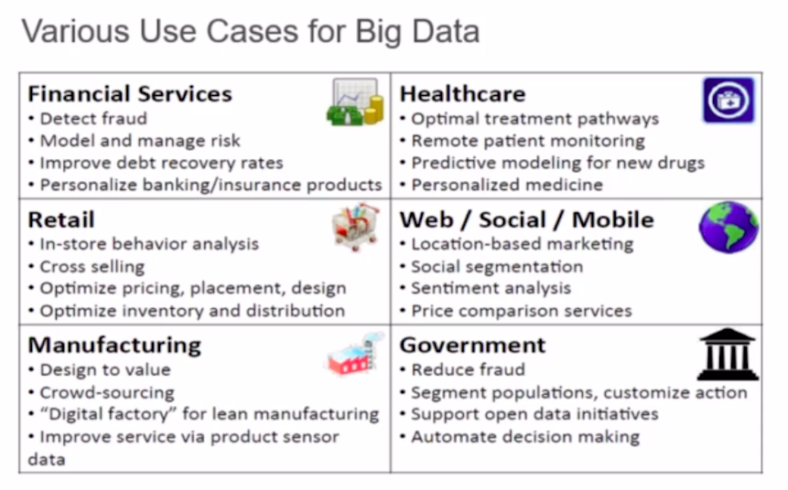

Challenges of Big Data

1. Storing the Data
2. Process the huge data – No point in just storing big data if we can’t process it
3. Handle the variety of data – Big data is unstructured or semi structured
4. Scalability
5. Cost

Previously, the big and rich organizations were having expensive hardware infrastructure and Software Applications to deal with big data. Like, the government, military, and Big research organizations. They were using big, expensive super computers for Processing the huge amount of Data. That cannot be done by other organizations or because of the expense and maintainability of the Hardware requirements.

